# Total Cost of Ownership of an VDL Electric Bus

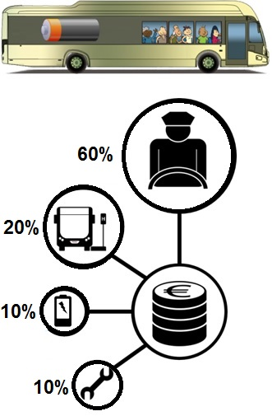  
Understanding the total cost of ownership of an electric bus fleet helps VDL and its customers designing the optimal bus fleet incl. chargers, maintenance, drivers & bus timetable and bus configurations (incl. correct battery type).

VDL is offering two types of buses: the city bus (low floor type (LF)) and an intercity bus (low entry type (LE)). The LF is a more heavier construction compared to the LE with which it can handle a bigger passenger load. To bring even more passengers a articulated type of the LF bus is available as well (LFA). The costs of the different bus types are (without the battery):

1x LE: € 350000

1x LF: € 390000

1x LFA: € 570000

As can be seen in the battery document of this assignment, VDL can offer two types of batteries: A medium power battery (MP) and high power battery (HP). For the battery costs the following prices can be used (per kWh energy):

MP: 720 €/kWh

HP: 1150 €/kWh

VDL can offer including the maintenance of a bus fleet with operating a workshop close to the depot where the buses are stored during the night. The maintenance costs of the bus can be directly linked to each driven kilometer. At a fixed mileage the bus has to come to the workshop to do the planned service and perform the required maintenance. For maintenance costs you can assume a cost of 0.30 €/km.

The energy for charging the buses will be offered by the company V-storage. The company was founded by VDL Groep and Scholt Energy Services. V-Storage reuses battery packs from electric buses in utility-scale energy storage systems. Strategically discharging the batteries leads to cost savings and by using the energy storage system to trade electricity extra revenue can be generated. Therefore VDL can offer energy for charging the buses for 0.10 €/kW.

As can be seen in the figure, the driver is the most expensive part of the implementation of electric busses in public transport. For the driver you can assume that he or she costs 40 €/hour.

Finally VDL offers four types of chargers for operating our electric buses (see also the document for charger specifications). Heliox is the Charging Solution Provider in many projects of VDL in the Netherlands. Different types of chargers can be selected with different charge rates. For the costs of the charging infrastructure, the following prices can be used:

30 kW system: €30000

250 kW system: €155000

450 kW system: €260000

# Bus specifications

|  |  |  |  |
| --- | --- | --- | --- |
| Bus types | LF | LFA | LE |
| Overall length [mm] | 12000 | 18750 | 9950 |
| Max. total vehicle weight [kg] | 19500 | 29000 | 14870 |
| Unloaded vehicle weight (excl. battery) [kg] | 10645 | 16125 | 7930 |
| Average passenger weight [kg] | 73 | 73 | 73 |

In the next chapter, batteries and chargers, two different battery chemistries available for the VDL Citea Electric can be found. For both battery types, the maximum battery pack size which can be fitted at the bus is **400 kWh** (because of limited space in the bus and on the roof of the bus).

For other bus specifications, see the Citea Electric folder which can be found in the supplied information.

# Batteries and Chargers

Table 1 & 2 describes the specifications of the battery system and chargers respectively.

*Table 1: Battery system specifications*

|  |  |  |
| --- | --- | --- |
| **Parameter** | **HP** | **MP** |
| Specific energy density(Wh/kg) | 60 | 70 |
| Operating nominal voltage(V) | 600 | 600 |
| Maximum charging current(A) | 625 A | 450 A |
| Maximum discharging current(C-rate) | 500 A | 450 A |
| Charging type | Fast charging | Slow charging |
| Cycle life(cycles) | 6500 | 3000 |

*Table 2: Charging system specifications*

|  |  |  |  |
| --- | --- | --- | --- |
| **Parameter** | **Type A** | **Type B** | **Type C** |
| Charging power(kW) | 30 | 250 | 450 |
| Charger type | Slow charging | Medium charging | Fast charging |
| Maximum continuous charging current(A) | 60 | 450 | 900 |

The available capacity of the batteries is sensitive to its operating temperature. The capacity variation as a function of temperature is shown in Figure 1. As mentioned in Table 1, the available capacity decreases as the battery ages over time. When the available capacity reaches 80% of the rated nominal capacity, the battery should be taken out of service and replaced with new ones. The capacity degradation (when charged and discharged with maximum rated current limits as specified), is described in Figure 2.

The recommended charging regime for each of the battery type is shown in Figure 3. The charging time for each battery type shall be governed according to this curve.

*Figure 1: Capacity variation with temperature*

*Figure 2: Capacity degradation with Aging*

Please keep below points in mind while developing the algorithm:

1. It is allowed to select different buses with different battery system.
2. It is required for MP battery to have one slow charging session after three continuous fast charging sessions.
3. Once the battery system is selected for each bus in the fleet, it is not possible to change the battery system during the operation.
4. Battery swapping is not allowed.
5. The batteries must only be operated in the recommended operating range, described in Table 1.

*Figure 3: Recommended charging profile for each battery type*

# Bus route specification and passenger profile

In Eindhoven, the buses will only travel with passengers from 06.00 in the morning upto 24.00 in the evening. During the night the buses have to be brought back to the depot. Table 1 describes the specifications of the route from and towards the depot. During the night the buses will be slow charged (30 kW charging) in the depot.

*Table 1:* Depot route properties

|  |  |
| --- | --- |
| Singe trip distance from (charging) depot to central station bus lot [km] | 1.65 |
| Single trip travel time from (charging) depot to central station bus lot [min] | 4 |

Table 2 describes the specifications of the bus routes route. Four time slots are considered, namely two rush hour slots and two low demand slots. Individual trips differ in distance, type of trip (single or round trip), duration, stop duration, passenger load and trip frequency. Note that Route 1 is only one way, so this route is actually divided into two parts, namely Route 1a and 1b where Route 1b is the return trip of Route 1.

The start and end time for a day’s schedule is flexible i.e. for each route, the buses can start the first trip between 5:30-6:30 [h] and similarly, the last trip can end between 23:30-00:30 [h].

*Table 2: Route specifications*

|  |  |  |  |  |  |
| --- | --- | --- | --- | --- | --- |
|  | timeslot 1  06:00-9:59 [h] | timeslot 2  10:00-15:59 [h] | timeslot 3  16:00-19:59 [h] | timeslot 4  20:00-00:00 [h] | stop duration |
| Route 1 (single trip distance 10 [km], duration 30 [min]) | | | | | Only at destination: 8 [min] |
| passengers to be moved | 700 | 700 | 700 | 700 |
| bus frequency [min] | 10 | 10 | 10 | 10 |
| Route 2 (round trip distance 10 [km], duration 40 [min]) | | | | | Every 300 [m] stop for 10 [sec] |
| passengers to be moved | 2000 | 300 | 2000 | 300 |
| bus frequency [min] | 10 | 20 | 10 | 20 |
| Route 3 (round trip distance 15 [km], duration 55 [min]) | | | | | Every 500 [m] stop for 10 [sec] |
| passengers to be moved | 2000 | 300 | 2000 | 300 |
| bus frequency [min] | 10 | 20 | 10 | 20 |
| Route 4 (round trip distance 7 [km], duration 20 [min]) | | | | | Every 700 [m] stop for 10 [sec] |
| passengers to be moved | 300 | 200 | 300 | 200 |
| bus frequency [min] | 20 | 30 | 20 | 30 |
| Route 5 (round trip distance 6 [km], duration 20 [min]) | | | | | Every 300 [m] stop for 10 [sec] |
| passengers to be moved | 2000 | 300 | 2000 | 300 |
| bus frequency [min] | 10 | 10 | 10 | 10 |
| Route 6 (round trip distance 20 [km], duration 60 [min]) | | | | | Every 1 [km] stop for 20 [sec] |
| passengers to be moved | 1500 | 200 | 1500 | 200 |
| bus frequency [min] | 10 | 20 | 10 | 20 |
| Route 7 (round trip distance 10 [km], duration 40 [min]) | | | | | Every 500 [m] stop for 10 [sec] |
| passengers to be moved | 3300 | 1000 | 3300 | 1000 |
| bus frequency [min] | 10 | 10 | 10 | 10 |
| Route 8 (round trip distance 25 [km], duration 70 [min]) | | | | | Every 1 [km] stop for 20 [sec] |
| passengers to be moved | 1600 | 800 | 1600 | 800 |
| bus frequency [min] | 20 | 20 | 20 | 20 |
| Route 9 (round trip distance 35 [km], duration 60 [min]) | | | | | Every 2 [km] stop for 20 [sec] |
| passengers to be moved | 600 | 200 | 600 | 200 |
| bus frequency [min] | 30 | 30 | 30 | 30 |
| Route 10 (round trip distance 30 [km], duration 60 [min]) | | | | | Every 3 [km] stop for 20 [sec] |
| passengers to be moved | 1000 | 600 | 1000 | 600 |
| bus frequency [min] | 30 | 30 | 30 | 30 |
| Route 11 (round trip distance 40 [km], duration 70 [min]) | | | | | Every 3 [km] stop for 20 [sec] |
| passengers to be moved | 400 | 100 | 400 | 100 |
| bus frequency [min] | 30 | 60 | 30 | 60 |
| Route 12 (round trip distance 35 [km], duration 60 [min]) | | | | | Every 2 [km] stop for 20 [sec] |
| passengers to be moved | 1000 | 200 | 1000 | 200 |
| bus frequency [min] | 30 | 60 | 60 | 30 |

Note: All routes start and end at the central station bus station.

# Weather data of Eindhoven

See also the document Weather_data_Eindhoven.txt on the supplied USB stick.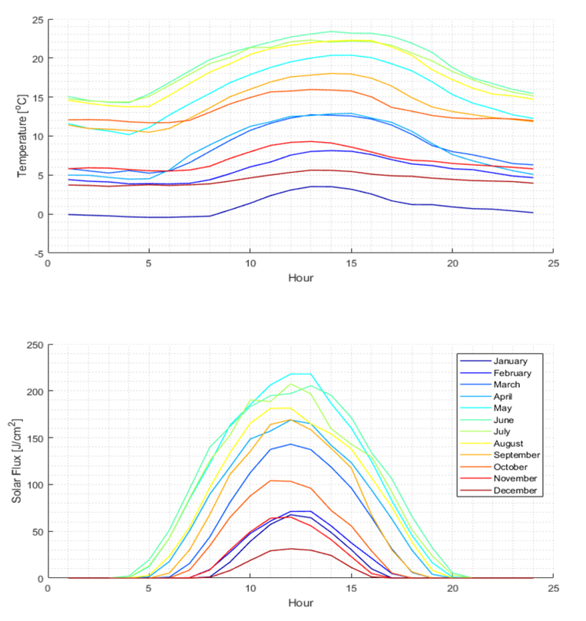

*Figure 1: Average monthly temperature (°C) and solar flux (J/cm2) for Eindhoven*

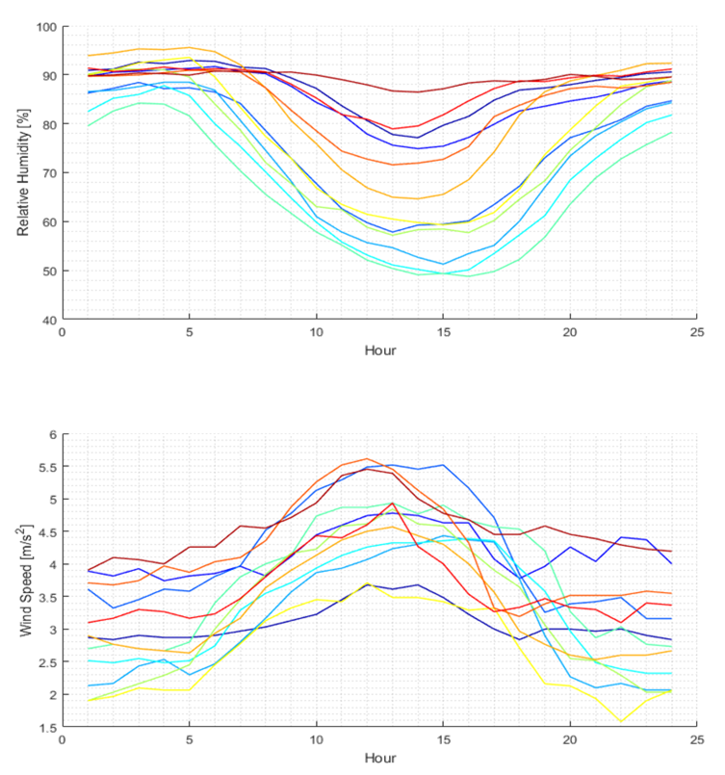

*Figure 2: Average relative humidity (%) and wind speed (m/s2) for Eindhoven*

# Average bus consumption

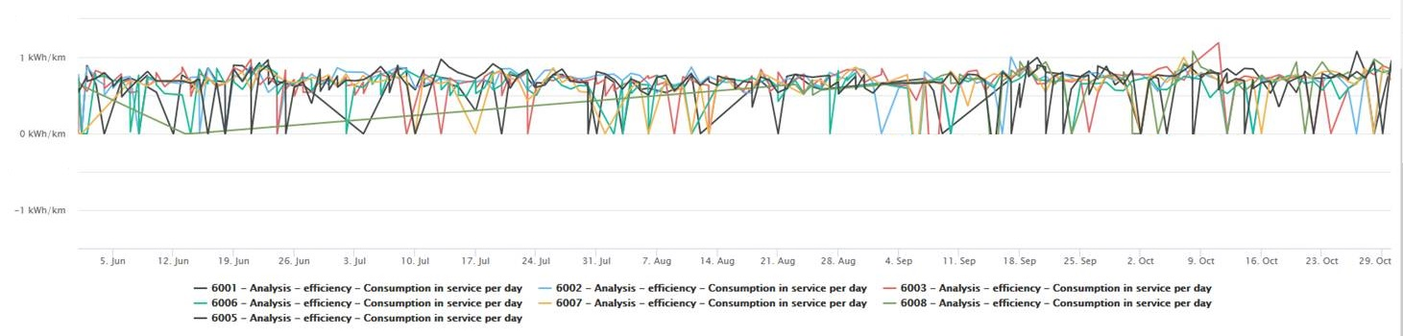The following consumption is given for a LF (12 meter city bus, see chapter bus specifications):

*Figure 1: Average consumption of an LF for the city of Eindhoven for 01-01 to 01-06.*

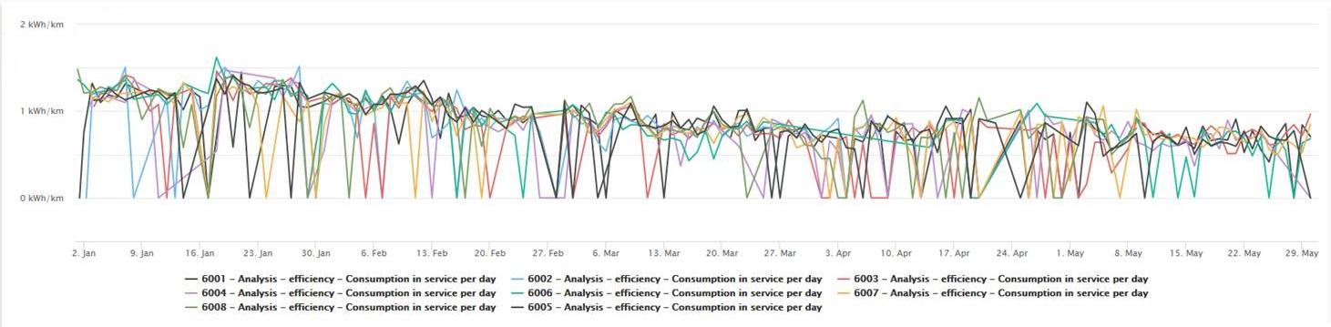

*Figure 2: Average consumption of an LF for the city of Eindhoven for 01-06 to 01-11.*